**COMP 6611**

**Software Measurement**

**Assignment 2**

**Group Members**

Sumair Zafar (7099347)

Umair Farooqui (6594794)

Muhammad Nadir (7143222)

Furqan Khuaja (6955665)

Jean Raymond Daher (7601417)

Muhammad Fahim Jan (6243045)

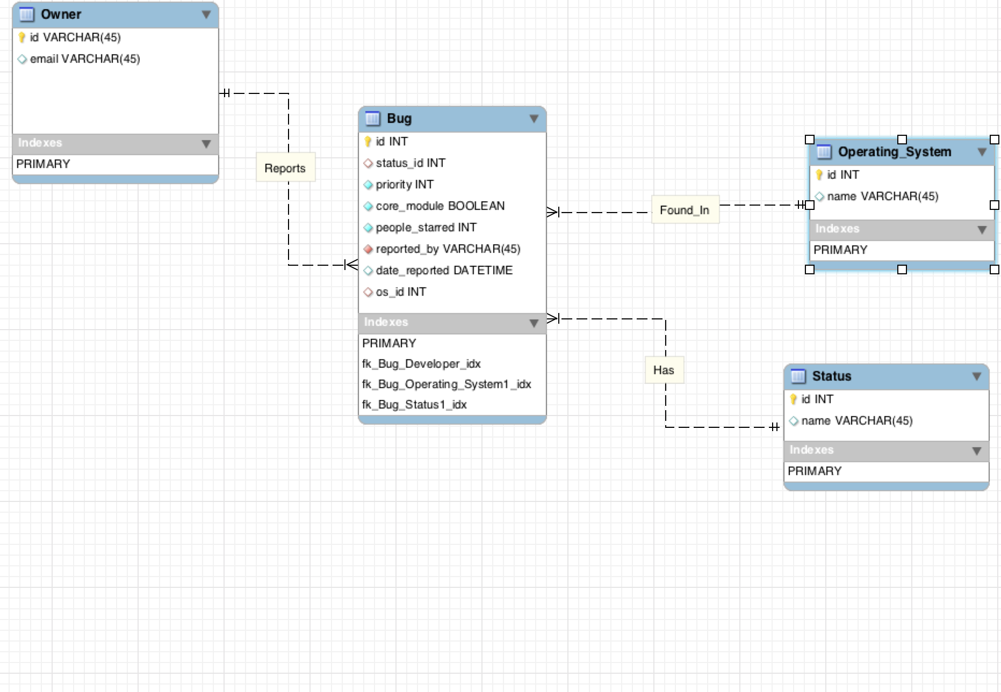

Figure : DB Schema

**Question. Are the bugs reported in the core modules being fixed as fast as the bugs reported in the non core modules?**

**Measures :**

**Total core module bugs** = 837

**Total core module bugs Fixed** = 697

**Difference** = 837 – 697 = 140

**Total Non core module bugs** = 60260

**Total Non core module fixed bugs** = 44396

**Difference** = 60260 – 44396 = 15864

**Ration of core to fixed** =1.2

**Ratio of non core to fixed** =1.35

**Analysis and Conclusion:**

Bugs in the core module are being resolved 0.15 times faster than errors in the non core modules.

From this data we can conclude that core bugs which has high priority are being resolved faster than the non core bugs. If we at any point the manager wants a shift in the amount of effort being spend on the core and non core bugs he can analyze this data so this is how he can manage the resources.